Docker assignment –
Apache httpd webside host on port 90
Container host on port 80
Launched EC2 instance – installed Docker

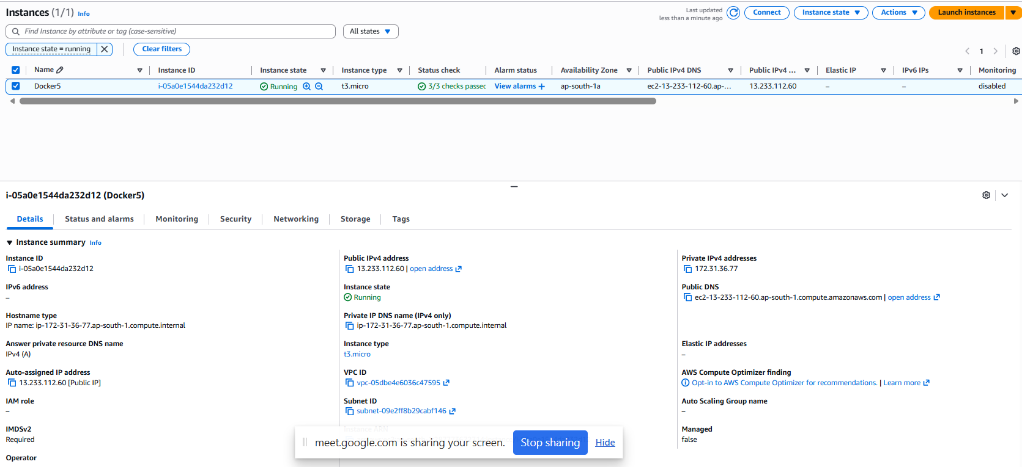

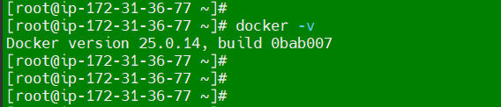
Created docker file
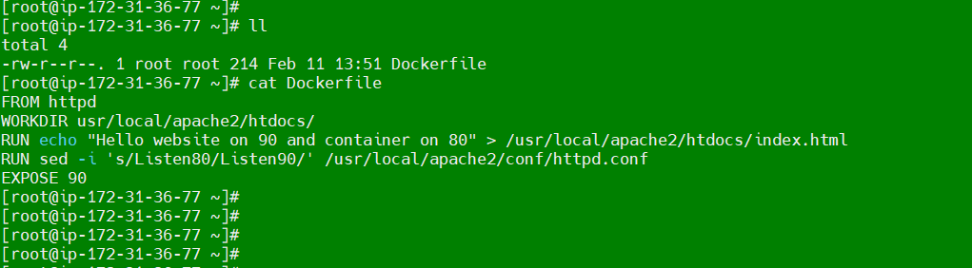
Build image

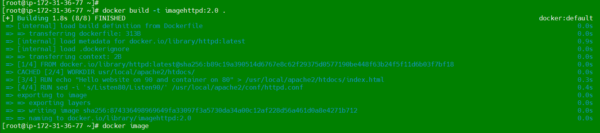

Checked container can run on port 80
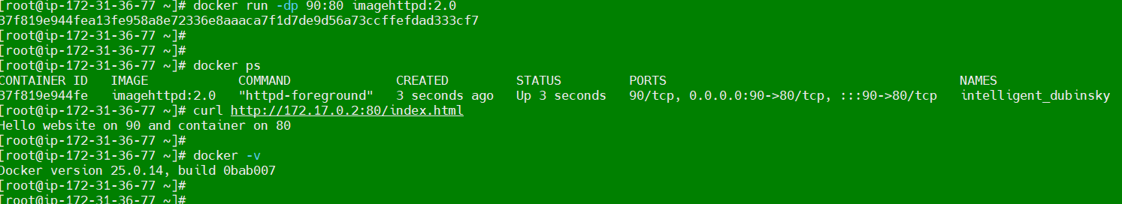
Website can host on port 90
